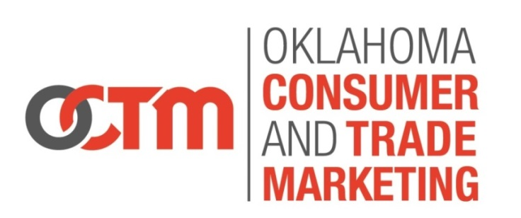
Group Travel Trade Program

Participation in the newly created Oklahoma Group Travel Trade program
offer many benefits to partners interested in developing/promoting to the group market.

Partner Benefits:

- Receive prospect list (includes meeting notes) automatically from Oklahoma Tourism and Recreation Department Consumer and Trade Marketing Division within thirty (30) days of the completion of a travel trade show. On average OTRD participates in 100-150 appointments each year.
- Inclusion in one (1) OTRD ad in Group Travel Leader and Select Traveler magazine.
- Inclusion on official state profile sheet that is distributed at each approved travel trade show.
- Current shows eligible with participation include: Ontario Motorcoach Association, NTA, Select Traveler, Missouri Bank Travel, TAP Dance, and Boomers in Groups. OTRD reserves the right to increase or reduce shows according to support and budget.

You must respond by July 31, 2016 to be included on the state profile sheet.
This program does NOT include American Bus Association.

Annual participation cost is $750. This is less than a 1/6 page ad in most travel trade publications.
Fee will be billed starting on July 1and due upon receipt of invoice

By signing this form I agree that:
1) Oklahoma Tourism and Recreation Department (OTRD) agrees to provide prospect list for each show listed above. OTRD reserves the right to increase or reduce shows according to support and budget.
2) Partner agrees that in utilizing the OTRD show prospect list, it will not disclose or transfer any portion of the prospect list in any form whatsoever, nor will it permit any third party, agent, employee, or contractor or their respective agents and employees to do so.
4) Program is Subject to change based on participation at potential contracted shows. Dates are subject to change. Oklahoma Tourism and Recreation Department has the right to alter program and/or delete shows; therefore, Agreement of Participation is based on external components and amendments could be made.
3) This agreement represents the final agreement between the parties and all negotiations both prior and contemporaneous are merged herein.

Organization ______________________________________________________________________
Contact __________________________________________________________________________
Address _________________________________________________________________________
City _______________________________________ State ______ Zip ______________________
Phone ______________________________ email _______________________________________
Signature ________________________________________________________________________

Return via email – todd@travelok.com fax – 405-522-9653 mail – 900 N stiles, OKC, OK 73104

